JAMMU DISTRICT SCHOOLS DATA
1.NAME : Jodhamal Public School (JMPS)
Establishment Year:1979
Affiliation:Central Board of Secondary Education (CBSE)
contact: 01-912466092
website: www.jhodamalschool.org
image: https://share.google/images/E1eA1pw1sY8Duu3rI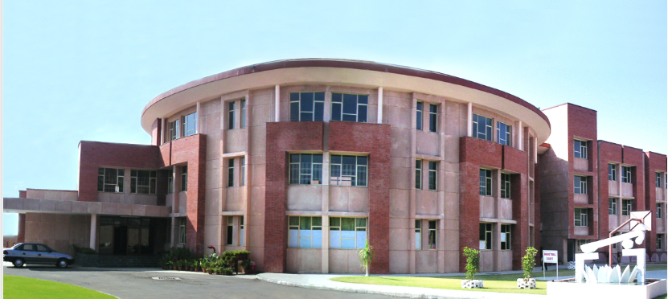
courses: aligned with the CBSE curriculum, covering academic subjects alongside extracurricular activities in arts, sports, and cultural events to foster well-rounded development.
curriculum: CBSE
2.NAME :Heritage school
Established year :2007
Affiliation :CBSE
Contact - heritageschooljammu@gmail.com
WEBSITE: heritageschooljammu.com
IMAGE: https://share.google/images/kGAIWmGx6AP0bJRyR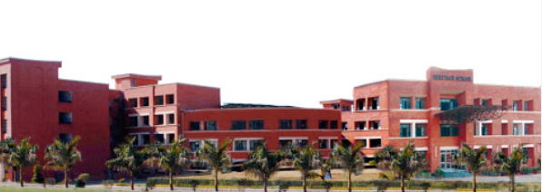
COURCES: the school emphasizes English, Mathematics, Science, and Social Studies, with specialized facilities like computer and EVS labs to support these subjects. The school also provides career counseling services to help students identify suitable courses and universities for their higher education.
curriculum: CctBSE
3.Name: KC international school
Established :2004
Affiliation :CBSE
Contact:+ 91-191-2954747
Website: kcinternationalschool.org
Image: https://share.google/images/4HN0uB4mmu2C7dp4j
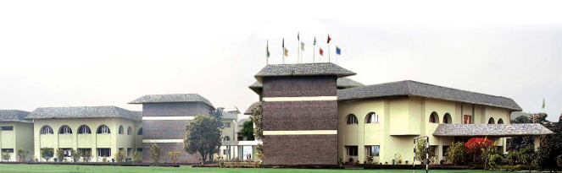
Courses: The school emphasizes practical, application-based learning to foster critical thinking and real-world application skills. For Senior Secondary students (Class XI & XII), they offer Science (Medical & Non-Medical), Commerce, and Humanities streams, with the curriculum designed to prepare students for competitive exams and a holistic understanding of subjects, including computer science, physical education, and painting as optional subjects in various streams.

Curriculum: a CBSE-affiliated curriculum, divided into Early, Primary, Middle, Secondary, and Senior Secondary programs.

4. NAME: JK Public School in Jammu
ESTABLISHED: 1992 or 1995
AFFILIATION : Central Board of Secondary Education (CBSE)
CONTACT : Phone: 070515 22290
Email: jkpublicschool@gmail.com
WEBSITE: jkpschool.com
IMAGE: https://share.google/images/94qxfGDUkSDXEzVg0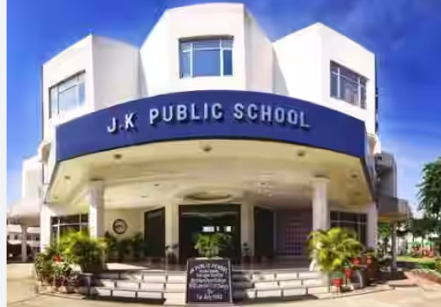

COURSES:
Levels:
Kindergarten to Class XII
Offers specialized streams for senior classes (Class XI & XII) in Medical, Non-Medical, Commerce, and Humanities. Provides a holistic curriculum that includes technological proficiency, intelligence, sensitivity, and self- awareness, aiming for well-rounded development.
CURRICULUM: Follows a CBSE-affiliated curriculum.

5. NAME: ARMY PUBLIC SCHOOLs
There are several Army Public Schools (APS) in Jammu, including APS Jammu Cantt., APS Kaluchak, APS Damana, and APS Ratnuchak
Army Public School, Jammu Cantt.
- Name:Army Public School Jammu Cantt
- Establishment:1984
- Website:http://apsjammucantt.com/apsjc/index.asp
- Contact:+91 908 603 0003, contact@apsjammucantt.com
- Affiliation:CBSE
- IMAGE: https://share.google/images/4Doa1MDhvQGzEcB7M
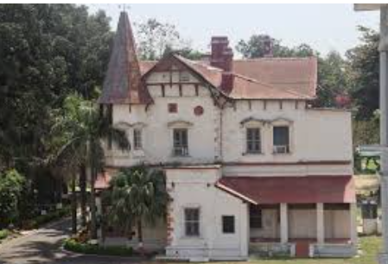
- Curriculum:Focuses on providing a comprehensive education, fostering intelligence, character, and a balanced personality.
Army Public School, Kaluchak
- Name:Army Public School, Kaluchak
- Website:https://www.apskaluchak.edu.in/
- Image: https://share.google/images/wZQxNrGPrI7T6lqHI
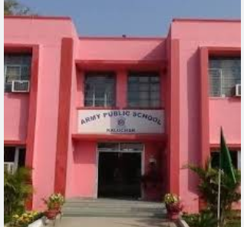
- Curriculum:Implements a value-based education through scholastic and co-scholastic activities, aiming to develop intellectual, social, emotional, and physical skills.
Army Public School, Damana
- Name:Army Public School Damana
- Affiliation Number:780013
- Website:https://apsdamana.org.in/
- Contact:+916006413231
- Image: https://share.google/images/DgZapMAuXVrtvni2S
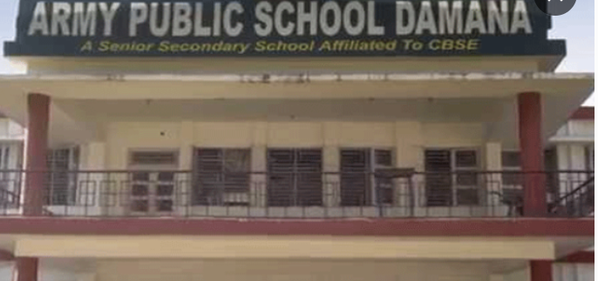
- Curriculum:Aims to provide quality education and develop well-rounded individuals.
Army Public School, Ratnuchak
- Name:Army Public School Ratnuchak
- Establishment:July 1, 1983
- Affiliation:CBSE
- Image: https://share.google/images/jgOEn5XgvrNtscwLu
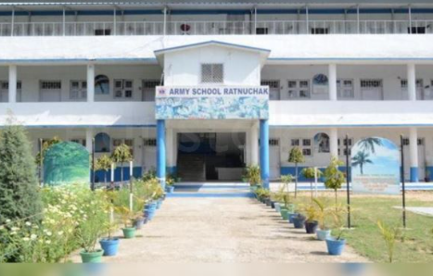
- Curriculum:Aims to achieve academic excellence and develop well-adjusted, adaptable, and integrated personalities.
6. NAME : SPRINGDALES SCHOOL
ESTABLISHED : 2013
AFFILIATION : Central Board of School Education (CBSE)
CONTACT: 01912642888
WEBSITE: https://www.springdales.org
IMAGE: https://share.google/images/xnK3HANmqoGIyoqpS
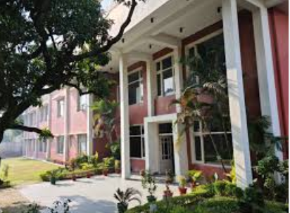
COURSES: follows cbse curriculum with a focus on holistic, activity-based, and experiential learning for classes Nursery to 12.
CURRICULUM: CBSE curriculum

